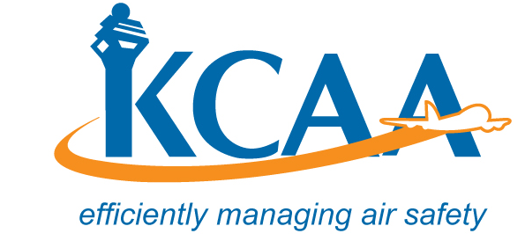 | Form;AC-AWS024

SUSPECTED UNAPPROVED PARTS REPORT FORM
KENYA CIVIL AVIATION AUTHORITY
SUSPECTED UNAPPROVED PARTS REPORT
Refer to page 2 for instructions on how to complete this form.
- Date the Part Was Discovered: | 2. Part Name:
3. Part Number: | 4. Part Serial Number:
5. Quantity: | 6. Assembly Name:  Assembly Number: | 7. Aircraft Make & Model:
8. Name, Address, and Description of the Company or Person Who Supplied or Repaired the Part:

- Operator Certificate # | - Supplier
- AME – Certificate # | - Production Approval Holder
- AMO Certificate # | - Manufacturer
- Distributor | - Other
- Owner/Operator | - Unknown
9. Description of the Issue:
10. Name and Address of (the Company or Person) Where the Part Was Discovered:
Name: | Street Address:
City: | State: | ZIP Code:
Country: | Phone Number:
Check One of the Following Applicable to the Company or Person Who Discovered the Part:
- Operator- Certificate # | - KCAA Inspector
- AMEL Certificate # | - KCAA/Office of Director General
- AMO Station - Certificate # | - Police Criminal Investigation Service
- Distributor | - Other Government Agency
- Supplier | - Foreign Civil Aviation Authority
- Owner/Operator | - Unknown
- Other
11. Date of This Report:

12. Check this box if you request anonymity - Do not complete blocks 13-15.

13. Name and Address of the Reporter:
Name: | Street Address:
City: | State: | ZIP Code:
Country: |  | Phone Number:
14. Check this box if you request confidentiality.
15. Check this box if you do not wish to receive an acknowledgment letter.
16. Check this box if you have attached additional information.
Instructions for Completing KCAA Form AWS024, Suspected Unapproved Parts Report
1. Record the date the part was discovered.
2. Record the part name (or a description of the part).
3. Record the part number or identification number of the part.
4. Record the serial number on the part, if applicable.
5. Record the quantity of parts.
6. Record the assembly name and assembly number (where the part was or could be installed).
Example: Part Name: Strut Part Number: PN 12345 Serial Number: 678 Quantity: 1
Assembly Name: Main Landing Gear Assembly Number: PN 90101112
Note: Record additional part numbers on page 3 or a blank sheet of paper with the following column headers:
Part Name — Part Number — Serial Number — Quantity — Assembly Name — Assembly Number
7. Record the type of aircraft the part was (or could be) installed on.
8. Record the complete name and address of the company or person who produced, repaired, and/or sold the part. Do not list a P.O. Box address unless a street address is not available.
Check the box that describes the company or person. Provide the certificate number, if known.
Operator- An KCAA-certificated company or person who undertakes directly by lease, or other arrangement, to engage in air transportation. | Supplier - A company or person who furnishes aircraft parts or related services, at any tier, to the producer of a product or part  thereof
AME - A person holding a KCAA AMEL with airframe and/or powerplant ratings.
AMO – Approved Maintenance Organization | Manufacturer – The original equipment manufacturer (OEM.)
Distributor - A broker, dealer, reseller or other person or agency engaged in the sale of parts | Other-Record other type of business.
Owner/Operator - The owner or operator of an aircraft. | Unknown

9. Record a brief narrative stating why you believe the part is not approved. Include a description of the part (improper configuration, suspect marking, different material, etc.), where it was obtained, and what type of documentation was supplied with it.
10. Record the complete name and address of the location where the part was found. Check the appropriate block to reflect the affiliation of the company or person who discovered the part.
11. Record the date the KCAA Form AWS024 is being submitted.
12. Check this box if you request anonymity (do not wish to provide your identity), and do not complete 13, 14 or 15.
13. Record your name, address and phone number, if desired. This information will enable the KCAA to contact you for additional information, if necessary.
14. Check this box if you request confidentiality of your personal information recorded in block 13.
15. Check this box if you do not wish to receive a letter acknowledging the KCAA’s receipt of KCAA Form;AC-AWS024.
16. Check this box if you have provided additional information (photos, invoices, certification statements, etc.)
Forward the completed KCAA Form AW024, Suspected Unapproved Parts Report,
KCAA eservices voluntary/mandatory reporting system OR
Kenya Civil Aviation Authority,
P.O Box 30163-00100,
AVIATION HOUSE, JKIA.
Phone: (254) 0206827470-5 , FAX: (254) 0206827808

