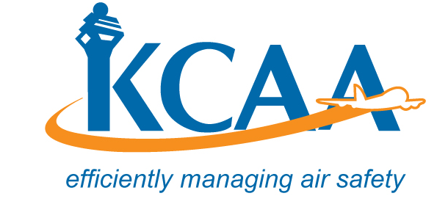 | Form: AC-AWS022

APPLICATION FOR NOISE CERTIFICATE
Nationality and Registration Marks: |  | Manufacturer and Manufacturer’s Designation of aircraft: |  |  |  | Aircraft Serial Number:
Name and Address of Operator
Engine Type/Model: |  |  | Propeller Type/Model: (where applicable)
Maximum Take-Off Mass: |  | Maximum Landing Mass:
Additional Modifications incorporated for the purpose of compliance with the applicable Noise Certification Standards:

Lateral/Full Power Noise Level: | Approach Noise Level: |  |  | Flyover Noise Level: | Overflight noise Level |  | Takeoff noise Level
Supporting Documentations attached :
APPLICATION AND DECLARATION
I hereby apply for a noise certificate in relation to the above aircraft in accordance with the Civil Aviation (Airworthiness) Regulations. I hereby certify that all applicable noise levels and test procedures are in compliance with the applicable noise standards in ICAO Annex 16 Vol 1. I further declare that all documents submitted in support of this application are true in every respect.

____________________________________ __________________
Name & Designation of Applicant Signature & Date

