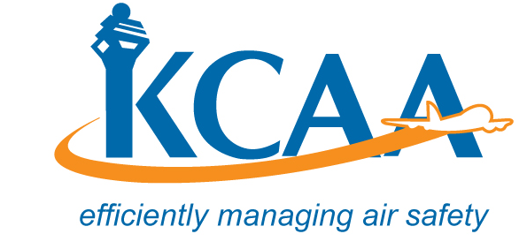 | Form: AC-AWS014A

MAJOR REPAIR AND MODIFICATION RECORD
(Airframe, Engine, Propeller or Appliance)
Print or type all entries.
1. Aircraft |  | Make |  |  |  |  |  |  |  |  |  | Model
 |  | Serial Number |  |  |  |  |  |  |  |  |  | Nationality and Registration Mark
2. Owner |  | Name (As shown on registration certificate) |  |  |  |  |  |  |  |  |  | Address (As shown on registration certificate)
Initial Acceptance Number & Date Issued;
3. Unit Identification |  |  |  |  |  |  |  |  |  |  |  |  | 4. Type
Unit |  |  | Make | Model |  |  |  | Serial Number |  |  |  |  | Repair |  | Modification
Airframe
Engine
Propeller
Appliance |  |  | Type
 |  |  | Manufacture
5. Conformity Statement
A. Organisation Name and Address |  |  |  |  |  |  | B. Kind of License/Organisation |  |  |  |  |  |  | C. Certificate/License  Number
 |  |  |  |  |  |  |  |  |  |  |  |  |  | (For an AMO include the appropriate ratings issued for the major repair or modification)
 |  |  |  |  |  |  | Approved Maintenance Organisation
 |  |  |  |  |  |  | Manufacturer
D. I certify that the repair and/or modification made to the unit(s) identified in item 3 above and described on the reverse or attachments hereto have been made in accordance with the requirements of the Civil Aviation (Airworthiness) Regulations and that the information furnished herein is true and correct to the best of my knowledge.
Date |  |  |  |  |  |  |  |  | Signature of Authorised Individual
6. Approval for Return To Service
Pursuant to the authority given persons specified below, the unit(s) identified in item 4 was inspected in the manner prescribed by the Kenya Civil Aviation Authority and is ACCEPTED REJECTED
BY | KCAA Inspector |  |  |  | Inspection Authorisation |  |  |  |  |  |  |  |  | Other (Specify)
BY | Maintenance  Organisation |  |  |  | Other
Date of Acceptance or Rejection |  |  |  |  |  |  | Certificate or Designation Number |  |  |  |  |  |  | Signature of Authorised Individual

