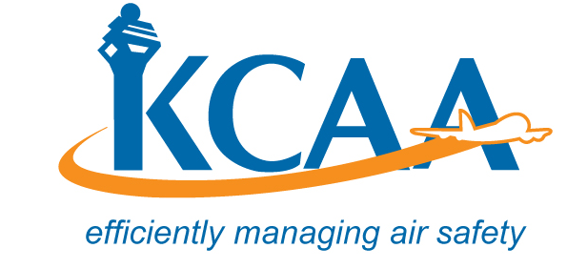 | Form: AC-AWS014

REQUEST FOR MAJOR MODIFICATION AND REPAIR DATA ACCEPTANCE

1. COMPANY NAME AND ADDRESS: |  |  | 2. COMPANY APPROVAL NO:
 |  |  | 3. MODIFICATION or REPAIR (Tick applicable box)
 |  |  | 4. ENGINEERING ORDER NUMBER:
5. A/C TYPE: |  |  | 6. REGISTRATION NO. AND MSN :
8.Details of MODIFICATION or REPAIR
9. Master Drawing Reference |  |  | 10. All Drawings Attached Yes No
11. Is Flight Manual Affected? Yes No If Yes, is Supplement Attached? Yes No
12. Design Authority Responsible: (Major Aircraft Manufacturer) e.g. FAA, EASA, UKCAA.
13. List Manuals Affected:
14. Page 2 Completed? Yes No Are all supporting Documents attached? Yes No
15. FOR AND ON BEHALF OF (Company Name)____________________________________________________

Name: Signature: Date:
FOR AUTHORITY USE ONLY
16. DATA ACCEPTED Authority Acceptance Number: |  |  |  |  | DATA NOT ACCEPTED
LIMITATIONS |  |  |  |  | Reasons for non-acceptance:
NAME: SIGNATURE: DATE:
17. Additional sheets attached NO | YES Number of additional sheets _________

In making this application the applicability of items on this table has been assessed and appropriately addressed.

18. Detailed Description:

19. Instructions Necessary For Installation:

20. Stress Analysis:

21. Power Supplies:

22. Cooling Requirements:

23. Aerial Position:

24. Fuses:

25. Component Listing:

26. Equipment Lighting:
27. Effects on other System:
28. Interface:

29. Crew Notices/Placards:
30. Modification Procedure:
31. Compatibility With Other Mods/Repairs:

32. The Maintenance Schedule is affected: Yes,

33. Tests:
34. Flight Tests:
35. Other Details:

The following are instructions for completing the application Form. The numbers correspond

to the numbers on the form:

1. Enter the company Name and Address
2. Enter the company Approval Number or Certificate Number
3. Tick appropriate box
4. Record the engineering order number.
- Record the aircraft type.
- Enter aircraft registration number.
- Enter the reason for the Modification or repair.
- Provide a detailed description of the repair or Mod.
- Give the Master drawing reference.
- List all relevant controlling drawing.
- Indicate the effect on the Flight Manual.
- Indicate the State of design which has provided approval for the design change or repair, such as FAA, JAA etc.
- List the other manuals that are affected, and may required supplements or amendments, and indicate when these changes are to be implemented.
- Indicate that Page 2. is properly addressed.
- Designated company representative shall record name, sign and date.
- For use by Authority only.
- Number of sheets used.
- Items 18-35 have been filled in as an example to indicate an acceptable method when a submission is made to the Authority. Each operator must address each item to indicate that all the listed factors have been considered as a minimum, and are included as appropriate.

