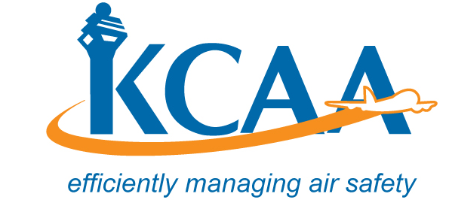 | Form: AC-AWS004-2

1. Details of Aircraft Owner/Operator
(a) Name of Owner/Operator: | (d) Physical Address:
(b) Nationality:
(c) Contact details: | (e) Postal Address:
(i) Telephone/Mobile : ………………….………………………………….
(ii) Fax: ……………………………..email…………………………………

2. Details of Aircraft | (i) Registration Marks:
(ii) Airframe | (iii) Engine | (iv) Propeller/Rotor
(a) Make: | (a) Make: | (a) Make:
(b) Model: | (b) Model: | (b) Model:
(c) Serial Number: | (c) Serial Number: | (c) Serial Number:
(d) Constructor: | (d) Constructor: | (d) Constructor:
(e) Year of construction: | (e) Year of construction: | (e) Year of construction:
- No. of Seats:  (including pilot) | (vi) Maximum Take-Off Mass | (vii) Landing Gear  - Fixed Landing Gear  - Retractable Landing Gear

3. The aircraft stated above is;

- New | Used
Newly Overhauled | Major components are combination of new and used.

4. Classification of Aircraft (Airworthiness Reg. 16);
- (i) Microlite | - (iii) Kit Built
- (ii) Amateur Built | - (iv) Other

5. Explain ‘Other’ in 4 (iv) above:
- State of Origin:

7. Additional Information about the Aircraft: (supplements may be attached to this Form)
8. In addition to general operating limitations for non-Type Certificated aircraft, any other information the applicant considers relevant for the purposes of KCAA prescribing operating limitations;
9. Declaration
I hereby declare that the particulars entered on this application form and its attachments (where applicable) are accurate in every respect and the aircraft mentioned above complies with the minimum requirements for safe flight and I am aware the aircraft has not been type-certified for airworthiness purposes.
10.
Name of Authorized Person :_________ Signature;________ Date: ________

