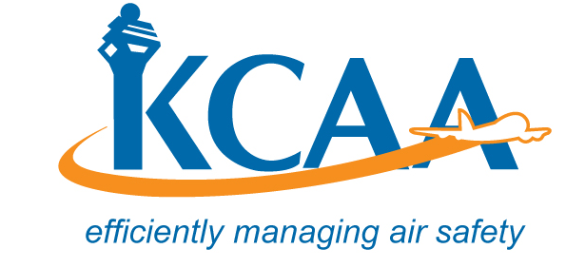 | Form: AC-AWS001C
APPLICATION FOR REGISTRATION OR RE-REGISTRATION OF AIRCRAFT
This Application Form when completed, should be forwarded to the Director General, NAIROBI and must be accompanied by the documents listed on the attached ANNEX I as appropriate.
Type and description of Aircraft (Including seating capacity)
Overall Dimensions.
Height.....................................................
Span (Open)................................................
Length....................................................
Span (folded)................................................
Number of Engines....................................................
Type of Engines.................................................................................. H.P....................................
Name and address of Constructor
Constructors Serial Number
Is the Aircraft on lease?
Is the aircraft already registered? If so give full particulars
Name and address of the Owner
Name and Address of lessee
Name and address of the Financier
Is the aircraft owned/operated wholly either by:
(a) The Government of Kenya
(b) Citizens of Kenya or persons bona fide resident in Kenya or such other persons as the Kenya Minister of Transport may approve
(c) And bodies corporate
(i) Established under and subject to the laws of Kenya, or
(ii) Established under and subject to the laws
- Of such country as the Kenya Minister of Transport may approve.
Usual station of Aircraft
I HEREBY DECLARE that the above particulars are true in every respect
Name and Signature of the Owner (Item 8 above) ............................................................................
Date ........................................................................
Name and Signature of the applicant.............................................................................................. Date of Application...................................................
FOR OFFICIAL USE. TO BE COMPLETED BY THE OFFICER ACCEPTING THE APPLICATION.
I hereby declare that I have checked the application form and the documents attached and I confirm that they are satisfactory and the application is accepted for the issue of the Certificate of Registration for aircraft .................................(type and registration marks).
I have therefore allocated the aircraft Registration Marks, 5Y....................
Name and designation of the officer...........................................................................
Signature of the officer.................................................................................................
Date application received........................................................................

