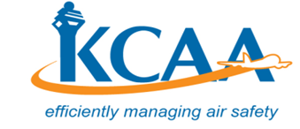 | FORM  FORM: O-OPS024-2  June 2018

DESIGNATED CABIN CREW EXAMINER APPROVAL

_________________________________________ is hereby approved as a company (Name and certificate number)

Designated Cabin Crew Examiner (DCCE), and authorised person and is authorised in accordance with Civil Aviation Regulations to conduct line checks on the aircraft types indicated below, on behalf of KCAA, subject to all of the conditions of issuance.

1. Aircraft type competence checks

2. Recurrent/re-qualification competence checks

3. Safety equipment practicals (drills)

4. Line Checks

5. Cabin crew instructor proficiency checks
(check as appropriate)

CONDITIONS OF ISSUANCE

1. Meet qualifications and maintain currency requirements in accordance with the DCCE manual.

2. Approval valid for ____________________________and ___________________
(Air Operator) (Aircraft Type)

3. Line checks shall be conducted pursuant to KCARs and the DCCE manual.

Failure to meet any conditions of issuance is grounds for suspension pursuant to KCARs

This authority supersedes and revokes all previously issued like authorities.
This authority shall remain valid until the earliest of:

- the date on which any condition of issuance is breached;
- The date on which this authority is revoked in writing, by the director general pursuant to KCARS.

Issued at KCAA HQs - Nairobi this _____day of__________, 20_______

Valid till the _____day of__________, 20________

Manager Flight Operations
For Director General KCAA

