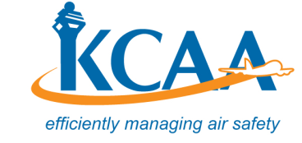

KEYA CIVIL AVIATION AUTHORITY
REVISED CIVIL AVIATION (SECURITY) REGULATIONS
STAKEHOLDERS’ COMMENTS

Please Print or Type Clearly
- PERSONAL DETAILS

Name:
Job Title:
Organization / Company:
Contact (email):
Telephone:

- COMMENTS

No. | Revised Regulation Title & Reference | Comment/Concern/Recommendation
 | Additional Comments / Proposals

Note: Complete this comment form and forward a soft copy to the Kenya Civil Aviation Authority via email (avsec@kcaa.or.ke) preferably on or before 10 January, 2020.

