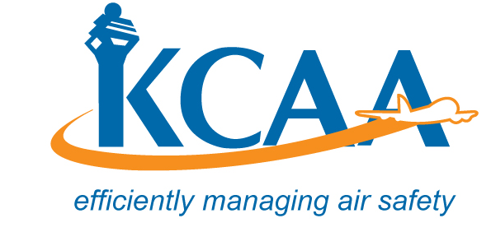 | Form: AC-AWS007-2

APPLICATION FOR FOREIGN APPROVED MAINTENANCE ORGANISATION CERTIFICATE AND RATINGS

Kenya Civil Aviation Authority |  |  |  |  | Application for Approved Maintenance Organization Certificate and Ratings
- Approved Maintenance Organization Name, Number, Location and Address |  |  |  |  |  | - Reasons for Submission
- Official Name of Maintenance Organization: |  |  | Number: |  |  | Original Application for Certificate and Rating  Change in Rating  Change in Location or Housing and Facilities  Change in Ownership  Other (Specify)
- Location where business is conducted:

- Official Mailing Address of Approved Maintenance Organization (Number, Street, City, State, & Zip)

- Doing Business As:

e. Line Maintenance Location
- Ratings Applied for: Ref: AMO CAR Reg. No.11
Aircraft |  | Engine – Propellers |  |  |  |  | Equipment & Instruments |  |  |  |  | Accessories  Class1 Mech. Acc.  Class2 Electrical Acc.  Class3 Electronic Acc.  Class4 APU.
Class 1 Composite Small Aircraft  Class 2 Composite Large Aircraft  Class 3 Metal Small Aircraft  Class 4 Metal Large Aircraft |  | Class 1 Piston <400hp  Class 2 Piston>400hp  Class 3 Turbine Engine  Class 1 Fix Pitch Props  Class 2 All other Props |  |  |  |  |  |  | Class 1 Comm Equip.  Class 2 Nav. Equip  Class 3 Rader Equip.  Class 1 Instr. Mech.  Class 2 Electrical  Class 3 Gyroscopic  Class 4 Electronic
Specialized Service (List Process Specification(s))
0
- List of Maintenance Functions contracted to an outside Organization:

- Applicants Certification
Name of Owner (Include name(s) of individual Owner, all partners, or corporation name given the state, province, or country and date of incorporation)

I hereby certify that I have been authorized by the approved maintenance organization identified in Item 1 above to make this application and that statements attached hereto are true and correct to the best of my knowledge.
Date: | Authorized Signature: |  |  | Print Name of Authorized Signature: |  |  |  |  |  | Title:

